Course Name | ITD 2343 – Object Oriented Programming with C#
Instructor | Mark L. Pranger
Student Name | Lauren Lashley
Due date | March 8, 2026
Grade | <grade earned here>
Grading Comments | <instructor comments here>

Week 9 – Programming Lab

Screenshot 1:
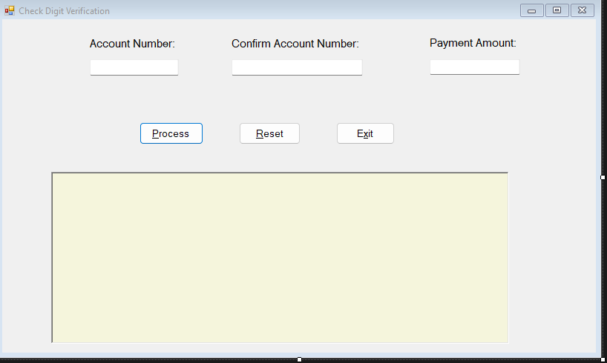
Screenshot 2:
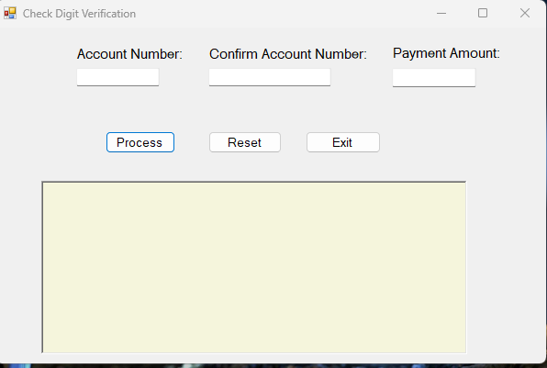

Screenshot 3 run with valid acct #:
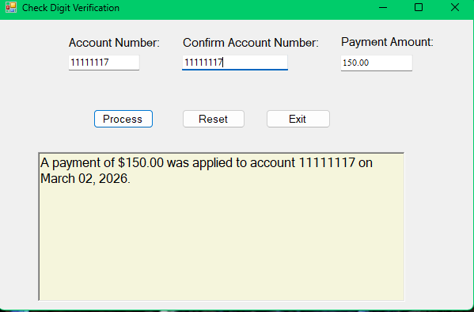

Screenshot 4 run with invalid acct #:
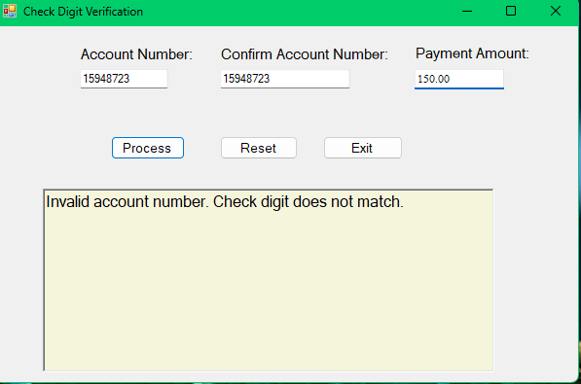

Screenshot 5 run with non # values:
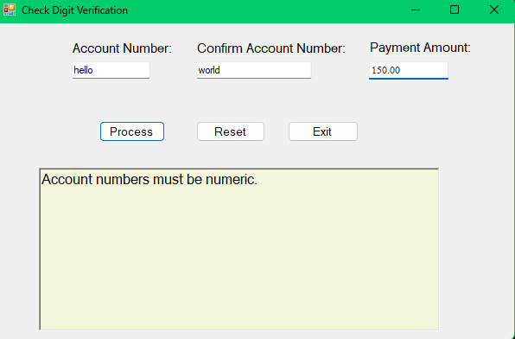

Screenshot 6 run with mismatch acct #:
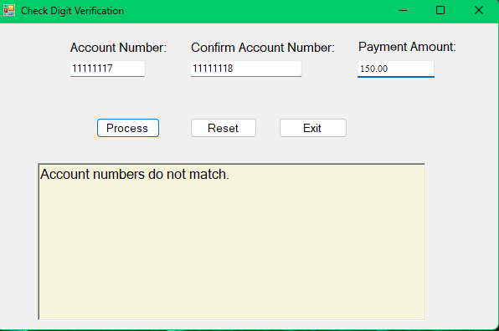

Screenshot 7 run with payment of $10,0.01:
